CelDial: Case Study Analysis
Group 1

INTRODUCTION
CelDial Corporation is a fictional company, it started as a manufacturer of cellular telephones but now it includes wide range of relate products.
As demand and size of products increased, they closed distribution channels and opened Sales Outlets.
It has opened new Manufacturing Plants. Sales Offices and Stores (Corporate and Retail).
In order to effectively measure the expansion/ growth rate so as to focus on performance, the company has requested series of reports from IT department.
The goal of the project would be to generate Sales and Revenue Reports by creating a Data Warehouse based on the given current data source.

OBJECTIVE
Objective of this project is to create a DWH and perform analysis on Cost & Revenue, and Relationship between the products that are manufactured by the company.
The two systems are defined as
1. Operational System

The Operational system supports day-to-day routine transactions/ processes.
Present system that the company uses is Operational System. Thus, cost and revenue figures are available for the company as a whole.
However, there is very little analytical data about sales, revenue and relationship at manufacturing plant, outlets level.

2. Data warehouse System
The proposed DWH System would take existing Operational System into consideration and collection of data would be created so that users (Management) would be able to analyze Sales and Revenue effectively.
With help of this system, they would be able to get answers (for decision making) such as,
When to stop making particular models/products,
Calculating actual cost, profits/ losses.

SCOPE OF THE PROJECT

Currently, the manufacturing costs are allocated at product level. But, the DWH should be flexible enough for future changes.
Direct costs and revenues associated with products

UNDERSTANDING & ANALYZING REQUIREMENTS - Design Approach:
Conceptual Model Design
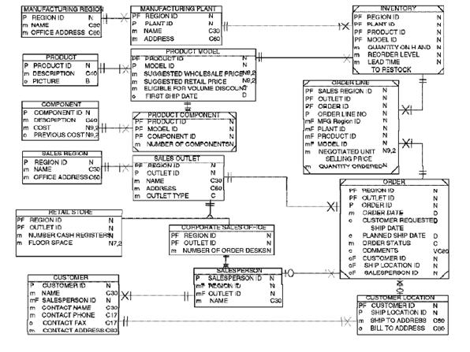

Entity Details

NO. | ENTITY | FACT/DIMENSION
1 | MANUFACTURING_REGION | MFG_REGION_DIM
2 | MANUFACTURING_PLANT | PLANTS_DIM
3 | INVENTORY | INVENTORY_FACT
4 | ORDER | ORDERS_DIM
5 | PRODUCT_MODEL | PRODUCT_DIM
6 | COMPONENT | COMPONENT_DIM
7 | SALES_OUTLET | SALES_OUTLET_DIM
8 | RETAIL_STORE | RETAIL_DIM
9 | CORPORATE_SALES_OFFICE | CORPORATE_SALES_OFFICE_DIM
10 | SALES_PERSON | SALESPERSON_DIM
11 | CUSTOMER | CUSTOMER_DIM
12 | ORDER_LINE | SALES_FACT

NO. | ENTITY | NUMBER OF ATTRIBUTES
1 | MANUFACTURING_REGION | (REGION_ID, NAME, OFFICE_ADDRESS)
2 | MANUFACTURING_PLANT | (PLANT_ID,REGION_ID,NAME,ADDRESS)
3 | INVENTORY | (REGION_ID, PLANT_ID, PRODUCT_ID, MODEL_ID,QTY_ON_HAND, REORDER_LEVEL)
4 | ORDER | ( ORDER_ID, ORDER_DATE, ORDER_STATUS, CUSTOMER_ID, REGION_ID, SHIP_LOCATION_ID, OUTLET_ID, REQ_SHIP_DATE, PLANNED_SHIP_DATE, ORDER_STATUS, SALESPERSON_ID)
5 | PRODUCT_MODEL | (PRODUCT_ID, MODEL_ID, COMPONENT_ID, NUMBER_OF_COMPS, DESCRIPTION, PICTURE, SUGGESTED_WHOLESALE_PRICE, SUGGESTED_RETAIL_PRICE, ELIGIBLE_FOR_VOLUME_DISCOUNT)
6 | COMPONENT | (COMPONENT_ID, DESCRIPTION, COST)
7 | SALES_OUTLET | (REGION_ID, OUTLET_ID, NAME, ADDRESS, OUTLET_TYPE)
8 | RETAIL_STORE | (REGION_ID, OUTLET_ID, FLOOR_SPACE)
9 | CORPORATE_SALES_OFFICE | (REGION_ID, OUTLET_ID, NUMBER_OF_ORDER_DESKS)
10 | SALES_PERSON | (SALESPERSON_ID, NAME, REGION_ID,OUTLET_ID)
11 | CUSTOMER | (CUSTOMER_ID, CUSTOMER_NAME, CONTACT_PHONE, ADDRESS, SHIP_LOCATION_ID, SHIP_TO_ADDRESS, BILL_TO_ADDRESS)
12 | ORDER_LINE | (SALES_REGION_ID, OUTLET_ID, ORDER_ID, ORDER_LINE_NO, MFG_REGION_ID, PLANT_ID, PRODUCT_ID, MODEL_ID, NEGOTIATED_UNIT_SP, QTY_ORDERED)

Logical to Physical Design Phase (Graphical)
Model flow to presented here...
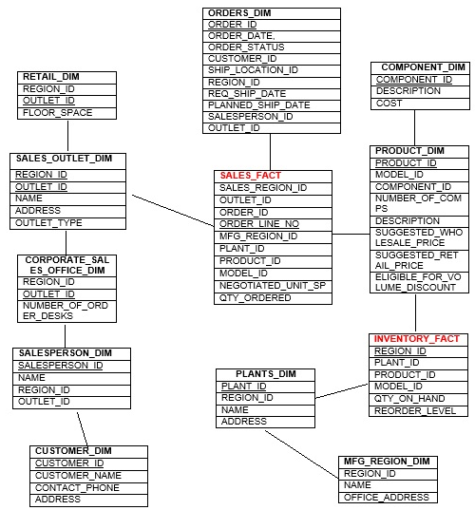
Physical Design

Data Usage | Standard
 |  | Datatype | Constraints
MFG_REGION_DIM | REGION_ID | NUMBER | PK
 | NAME | VARCHAR(30)
 | OFFICE_ADDRESS | VARCHAR(60)
PLANTS_DIM | PLANT_ID | NUMBER | PK
 | REGION_ID | NUMBER
 | NAME | VARCHAR(30)
 | ADDRESS | VARCHAR(60)
INVENTORY_FACT | REGION_ID | NUMBER | PK/FK
 | PLANT_ID | NUMBER | PK/FK
 | PRODUCT_ID | NUMBER | PK/FK
 | MODEL_ID | NUMBER | PK/FK
 | QTY_ON_HAND | NUMBER
 | REORDER_LEVEL | NUMBER
ORDERS_DIM | ORDER_ID | NUMBER | PK
 | ORDER_DATE, | DATE
 | ORDER_STATUS | VARCHAR(10)
 | CUSTOMER_ID | NUMBER
 | SHIP_LOCATION_ID | NUMBER
 | REGION_ID | NUMBER
 | REQ_SHIP_DATE | DATE
 | PLANNED_SHIP_DATE | DATE
 | SALESPERSON_ID | NUMBER
 | OUTLET_ID | NUMBER
PRODUCT_DIM | PRODUCT_ID | NUMBER | PK
 | MODEL_ID | NUMBER
 | COMPONENT_ID | NUMBER
 | NUMBER_OF_COMPS | NUMBER
 | DESCRIPTION | VARCHAR(60)
 | SUGGESTED_WHOLESALE_PRICE | NUMBER(8,2)
 | SUGGESTED_RETAIL_PRICE | NUMBER(8,2)
 | ELIGIBLE_FOR_VOLUME_DISCOUNT | BOOLEAN
COMPONENT_DIM | COMPONENT_ID | NUMBER | PK
 | DESCRIPTION | VARCHAR(60)
 | COST | NUMBER(8,2)
SALES_OUTLET_DIM | REGION_ID | NUMBER | PK/FK
 | OUTLET_ID | NUMBER | PK
 | NAME | VARCHAR(30)
 | ADDRESS | VARCHAR(60)
 | OUTLET_TYPE | VARCHAR(20)
RETAIL_DIM | REGION_ID | NUMBER
 | OUTLET_ID | NUMBER | PK
 | FLOOR_SPACE | NUMBER(7,2)
CORPORATE_SALES_OFFICE_DIM | REGION_ID | NUMBER
 | OUTLET_ID | NUMBER | PK
 | NUMBER_OF_ORDER_DESKS | NUMBER
SALESPERSON_DIM | SALESPERSON_ID | NUMBER | PK
 | NAME | VARCHAR(30)
 | REGION_ID | NUMBER
 | OUTLET_ID | NUMBER
CUSTOMER_DIM | CUSTOMER_ID | NUMBER | PK
 | CUSTOMER_NAME | VARCHAR(30)
 | CONTACT_PHONE | NUMBER(12)
 | ADDRESS | VARCHAR(60)
 | SHIP_LOCATION_ID | NUMBER
 | SHIP_TO_ADDRESS | VARCHAR(60)
 | BILL_TO_ADDRESS | VARCHAR(60)
SALES_FACT | SALES_REGION_ID | NUMBER | PK/FK
 | OUTLET_ID | NUMBER | PK/FK
 | ORDER_ID | NUMBER | PK/FK
 | ORDER_LINE_NO | NUMBER | PK/FK
 | MFG_REGION_ID | NUMBER | PK/FK
 | PLANT_ID | NUMBER | PK/FK
 | PRODUCT_ID | NUMBER | PK/FK
 | MODEL_ID | NUMBER | PK/FK
 | NEGOTIATED_UNIT_SP | NUMBER(8,2)
 | QTY_ORDERED | NUMBER

Presented by:
Anamika Dhar
Mayank Sahdev
Kiran Kumari

